

**VISHWA VISHWANI INSTITUTE OF SYSTEMS AND MANAGEMENT**

**PGDM**

**Sentiment Analysis of KFC Company**

**Submitted by**

**(TALLA VARUN GOUD)**

**(20099)**

**Course Title & Code : Introduction to Machine Learning**

**Semester & Year : 3st Sem & 2nd Year**

**Course Faculty : Tarun Raavi**

**Date of Assignment : 23-10-2025**

**Last Date of Submission : 24-10-2025**

**Analysis**

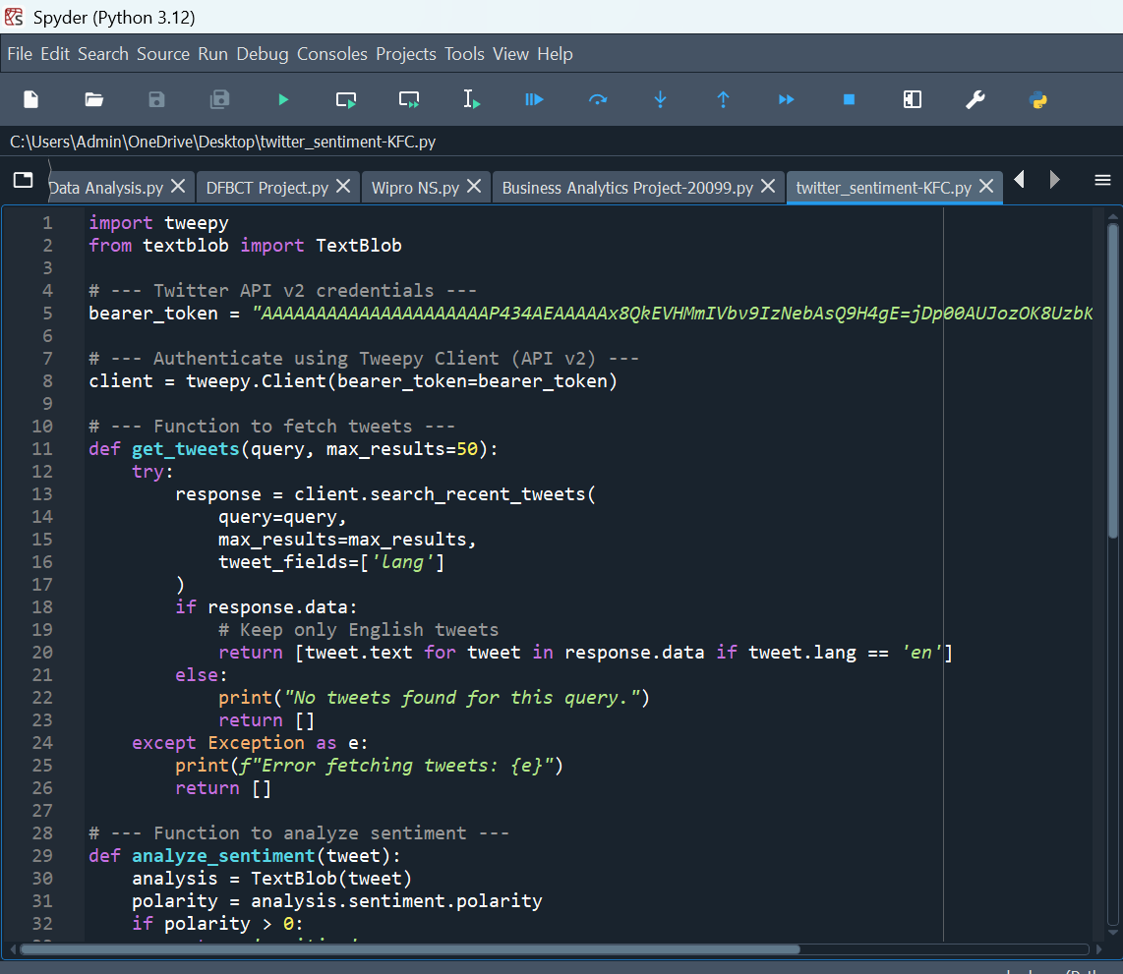

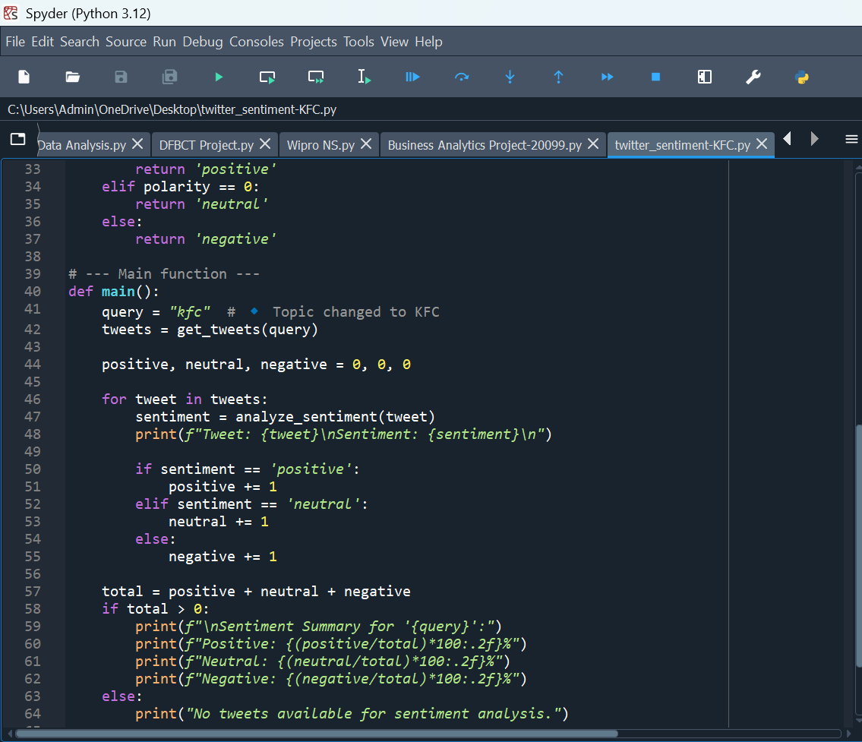

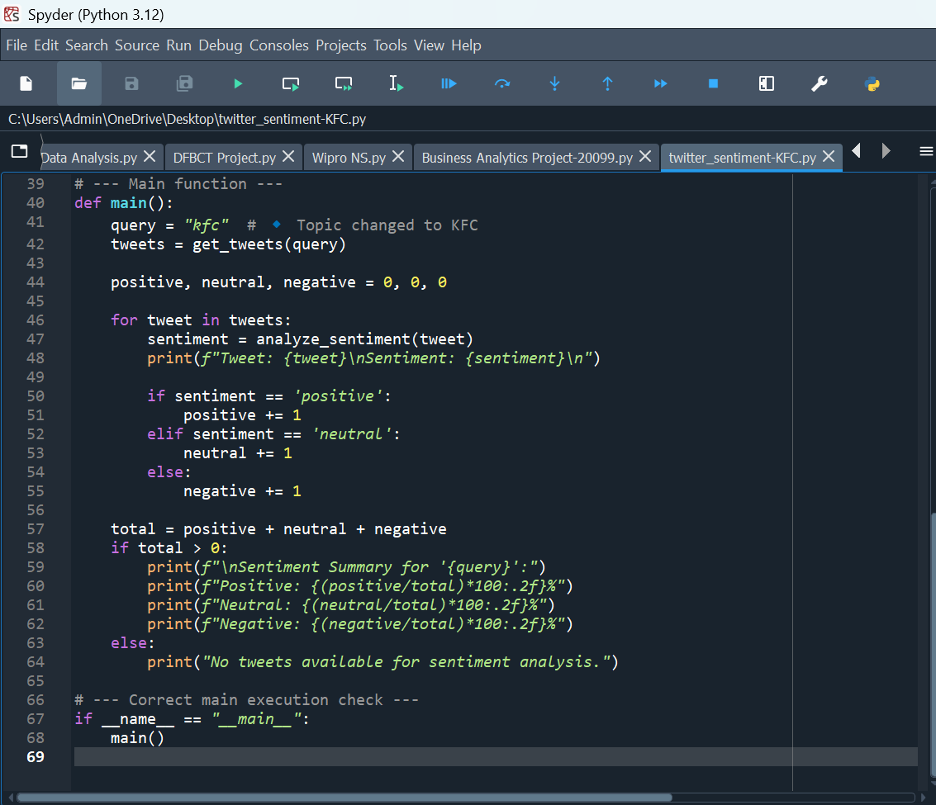

**Output:**

